**SPRINT 0**

**REVIEW**



**Author: Imagineers Team**

**Date: 2/1/2017**

**Revision history**

|  |  |  |  |
| --- | --- | --- | --- |
| **Version** | **Date** | **Author** | **Notes** |
| **1.0** | 2/1/2017 | Thạch Nguyễn |  |
|  |  |  |  |
|  |  |  |  |

**TABLE OF CONTENT**

I. SPRINT 0- BACKLOG 4

II. SPRINT 0- BURNDOWN 4

III. SPRINT 0- TASK REPORT 5

IV. SPRINT 0- DOD CHECKLIST 6

V. SPRINT 0 - SUMMARY 7

# SPRINT 0- BACKLOG

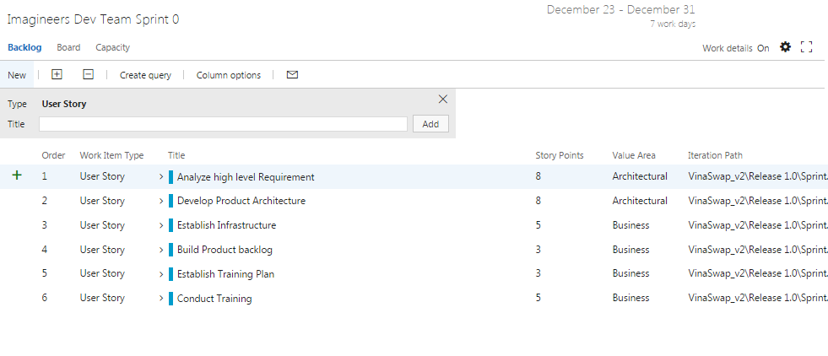

# SPRINT 0- BURNDOWN

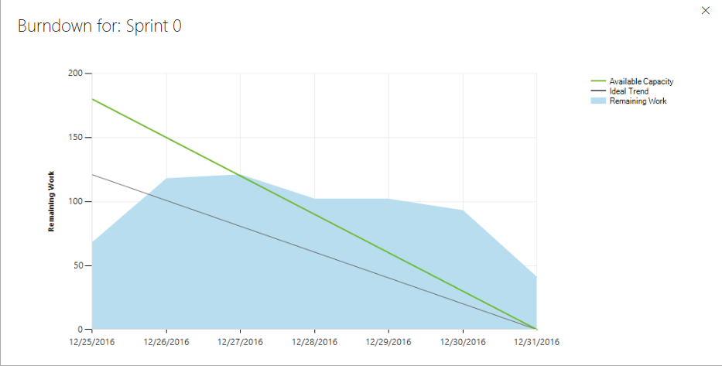

* Total estimated effort hours: 154 hours
* The actual effort hours: 110 hours
* The undone tasks hours: 44 hours

# SPRINT 0- TASK REPORT

|  |  |  |  |  |  |
| --- | --- | --- | --- | --- | --- |
| User story | Task | Assigned | Estimation (hrs) | Actual  (hrs) | Status |
| Analyze high level requirement  Conduct Training | Collect Requirements from meeting | Việt Đặng | 2 | 2 | DONE |
|  | Generate Business context | Phương Nguyễn | 5 | 5 | DONE |
|  | Write epic feature | Phương Nguyễn | 10 | 8 | DONE |
|  | Write user stories | Phương Nguyễn | 5 | 5 | DONE |
| Develop product architecture | Individual research Architecture | Thach Nguyen | 5 | 5 | DONE |
|  | Individual research Architecture | Phương Nguyễn | 5 | 2 | not done |
|  | Individual research Architecture | Việt Đặng | 6 | 3 | not done |
|  | Individual research Architecture | Chánh Trẩn | 10 | 3 | not done |
|  | Individual research Architecture | Quang Nguyễn | 5 | 4 | not done |
|  | Individual research Architecture | Tài Nguyễn | 5 | 5 | DONE |
|  | Write Architecture decisions | Thach Nguyen | 10 | 10 | DONE |
|  | Draw Dynamic view | Việt Đặng | 2 | 2 | DONE |
|  | Draw static view | Tài Nguyễn | 5 | 4 | not done |
|  | Draw physical view | Chánh Trẩn | 5 | 5 | DONE |
| Establish Infrastructure | Set up environment | Chánh Trẩn | 5 | 3 | not done |
|  | Review infrastructure | Thach Nguyễn | 5 | 5 | DONE |
| Build Product backlog | Collect and Prioritize User stories | Phương Nguyễn | 2 | 2 | DONE |
| Establish Training Plan | Write training plan | Quang Nguyễn | 2 | 2 | DONE |
| Conduct Training | Individual training | Thach Nguyen | 10 | 8 | not done |
|  | Individual training | Phương Nguyễn | 10 | 4 | not done |
|  | Individual training | Việt Đặng | 10 | 5 | not done |
|  | Individual training | Chánh Trẩn | 10 | 8 | not done |
|  | Individual training | Quang Nguyễn | 10 | 6 | not done |
|  | Individual training | Tài Nguyễn | 10 | 4 | not done |

# SPRINT 0- DOD CHECKLIST

|  |  |  |  |
| --- | --- | --- | --- |
| Category | Detail | Artifacts | Status |
| User Story Clarity | User stories selected for the sprint are complete with respect to product theme, understood by the team, and have been validated by the detailed acceptance criteria. | Product backlog/ User story | Done |
| Tasks Identified | Tasks for selected user stories have been identified and estimated by the team. |  | Done |
| Built product backlog ( high level ) | High level product backlog is built with customer approved | Imagineers-Productbacklog | Done |
| High level architecture | High level architect is developed with 3 views   * Static view * Dynamic view * Physical view | Imagineers-Architecture | The static view is not done |
| Training plan | Training plan is developed | Imagineers-TrainingPlan | Training plan is developed |
| Conduct training | Conduct training among team members | Imagineers-TrainingReport | Due to poorly estimated and technical decision the training progress is not done by the team |

# SPRINT 0 - SUMMARY

* There are a lot of undone task leads to failure in done the stories
  + All team member Individual training
  + Set up environment
  + Draw static view
  + Individual research Architecture
* It requires the team to work during the day off to finish the task on time for sprint execution
* Team needs to have a plan and technical solution for project.
* Team needs to fix this right away. If not it can cause the product to not finish on time